AWS Skill Builder: Sign-Up for an Account

This guide provides step-by-step instructions on how to Create or Sign-up for an AWS Skill Builder account.
Step 1. Go to AWS Skill Builder
Navigate to the AWS Skill Builder landing page, https://skillbuilder.aws/ using one of the following browsers:
The AWS Training and Certification experience works best on:
- Google Chrome (2 most recent major versions)
- Mozilla Firefox (2 most recent major versions)
- Microsoft Edge: (2 most recent major versions)
- Safari (2 most recent major versions)
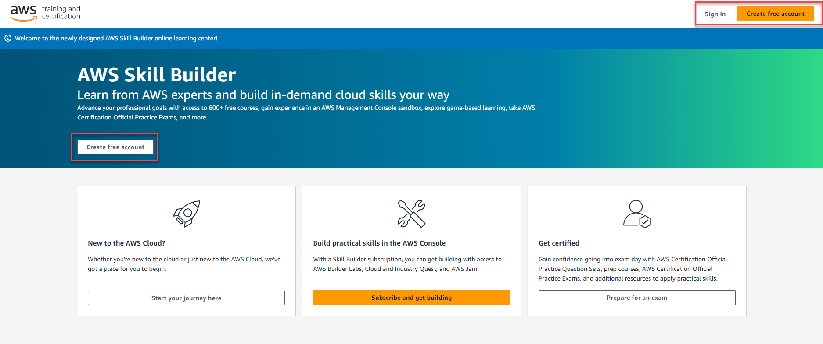
Click “Sign In” or either of the “Create free account” buttons. You will then be transferred to a page to choose between Sign-In and Account Creation choices, using either:
- AWS Builder ID (launched October 2023)
- Login with Amazon
- Organization SSO, AWS Partner Network, or Amazon Employee Single Sign-On: DO NOT USE THESE METHODS AT THIS TIME.

Click “Login with Amazon” or “AWS Builder ID.” Steps 2a, 2b, and 2c will walk you through actions to complete either choice:
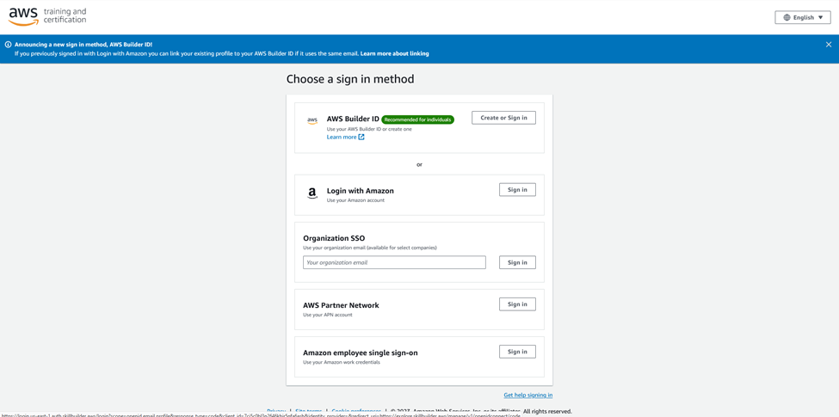

Step 2a. If using a current Amazon.com retail account
If you would like to use an Amazon.com retail account that you currently possess, sign in with that email and password, click “Allow”, click “Accept terms”, then proceed to Step 3. If you prefer, you can create a new Amazon.com retail account with any name and email address that you choose. See step 2b if this is your case.
The user needs to ensure they can reach the email associated with their Amazon.com retail account on the day of the training, in order to access course materials.
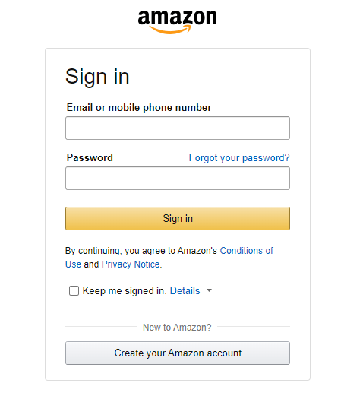
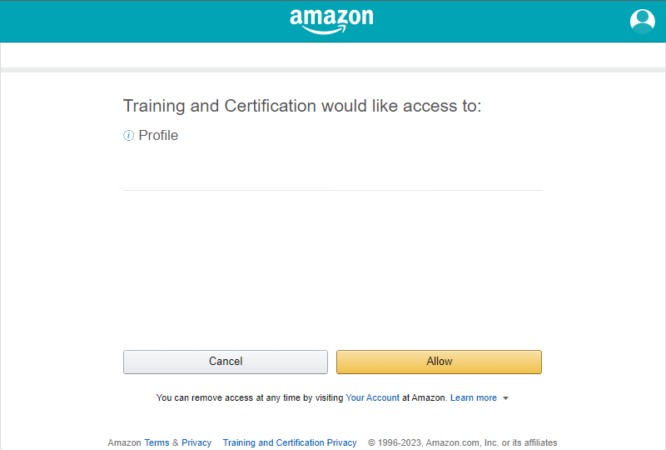

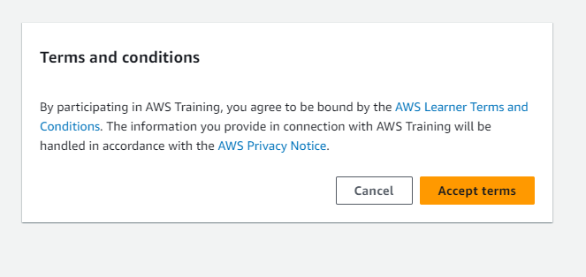

Step 2b. If you prefer to create a new Amazon.com retail account
The name and email for this account can be anything that you prefer. When creating a new Amazon.com account, verification is required by receiving a code sent to the email address used.
The user needs to ensure they can reach the email associated with their Amazon.com retail account on the day of the training, in order to access course materials.

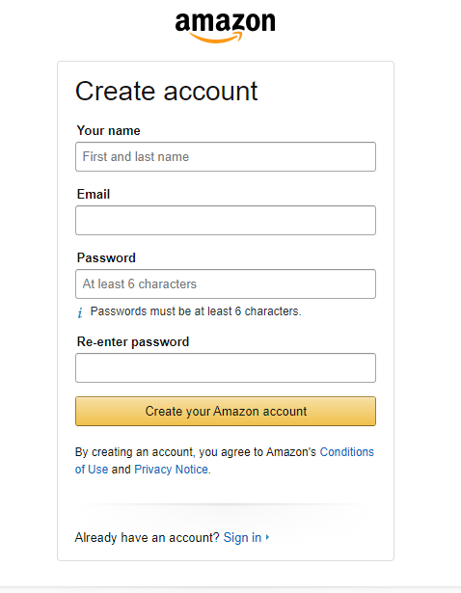
If creating a new Amazon.com retail account you will need to verify the email address by entering the OTP that was sent.
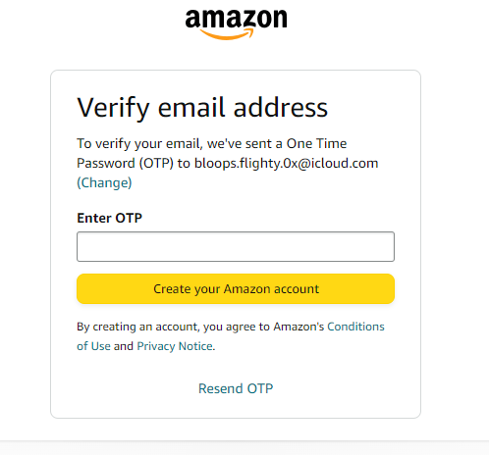
Step 2c. If you prefer to create an AWS Builder ID
The name and email for this account can be anything that you prefer. When creating a new AWS Builder ID, AWS requires verification by receiving a code sent to the email address used.
First, click on “Create or Sign In” on the “Choose a sign in method” page

Next, enter your email address preferred for your AWS Builder ID, and click “Next”
Next, enter your name (FYI – the name you enter here might be visible to other people using AWS), and click “Next”

Next, enter the verification code sent to your email address used in the two previous steps, and select “Verify”
Next, create your password for the AWS Builder ID, and select “Create AWS Builder ID”
Once your AWS Builder ID is created, you will be prompted to link your AWS Builder ID with your “Login with Amazon,” taking you through steps in Step 2a. above.
Step 3. Input information for the AWS Skill Builder profile
Once an Amazon.com retail account has been created, or if you logged in with your existing Amazon.com retail account or AWS Builder ID (and have not logged into the AWS Training site before) you will be presented with this profile creation screen. This information can be the same as your Amazon.com retail account information, or you can change it if you want. Please note the considerations below the screenshot.
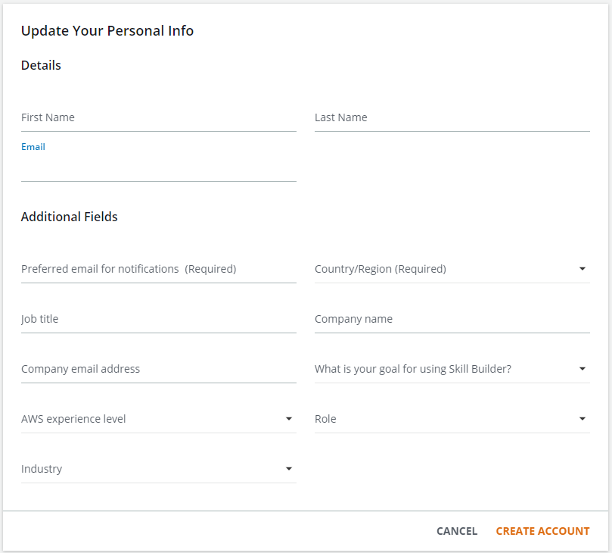
Note: Users can use any name and email they choose, but should consider:
- They will be recognized by that name and communications will go to the associated email
- All course completion certificates will be issued in the name that is listed in the profile
Get Started!
Once this is complete, you will have access to hundreds of no-cost digital training products from the AWS commercial catalog!

For more information, contact fed-training@amazon.com

